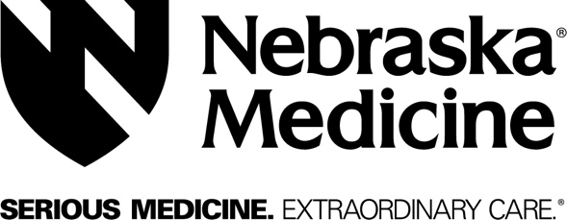 MEMO

{Department Name}
98 {xxxx} Nebraska Medical Center
Omaha, Nebraska 68198-7460
Telephone: 402.xxx.xxxx
FAX: 402.xxx.xxxx

Date:
To:
From

Message

If you do not receive the correct number of pages transmitted, Call (402) 55x-xxxx immediately.

CONFIDENTIALITY STATEMENT
This communication is intended only for the use of the individual or entity to which it is addressed and may contain information that is privileged and confidential. If you are not the intended recipient, or the employee or agent responsible for delivering the communication to the intended recipient, you have received this communication in error and are prohibited from reading, printing, or disclosing any of the information contained in it. If you have received this communication in error, please notify the sender immediately by telephone to arrange for the return or destruction of these documents.

