Email Signatures Instructions:
Please help us provide a unified appearance to our patients and the public.
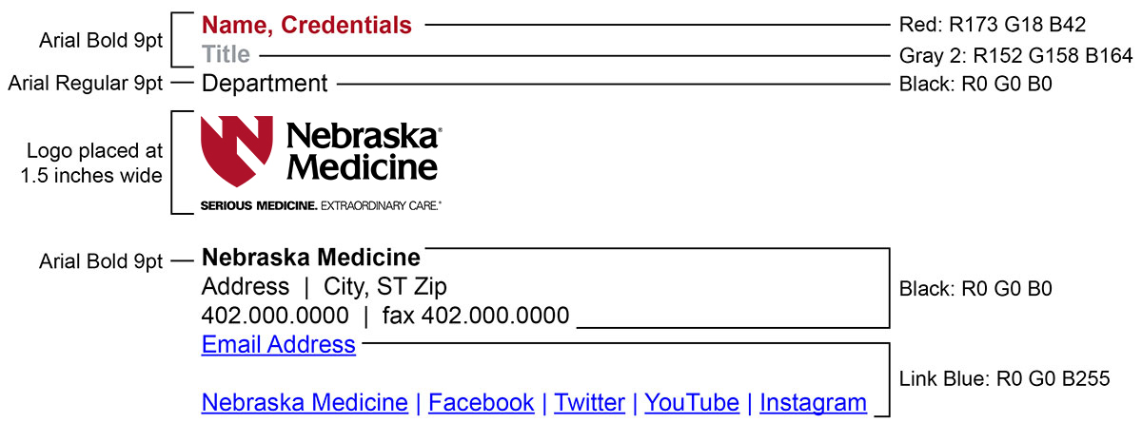
For consistency, each email signature within the Nebraska Medicine organization should follow a clear, specific format. Update your current email signature to match the following example. Your email signature should be in Arial font. The Nebraska Medicine logo can be included, as shown below. There should not be any wallpaper in the background of your email messages.

Outlook Instructions:
Update your Outlook signature by opening a new email, then click on “Signature” within its toolbar.
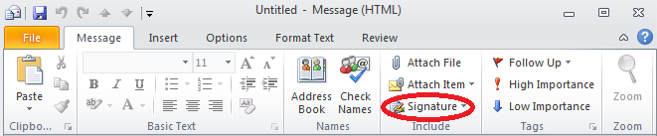
Select “Signatures” and when a new window opens, choose “New.”
Name your new signature and click “ok.”
Copy the example on the following page, and paste it into your new email signature by highlighting it with your mouse, hitting Control + C and then pasting it into the new window by using Control + V. Edit the text to match your personal contact information.
Delete your old email signature. Make sure your new email signature is selected for new messages and replies/forwards as you prefer. Click “ok.”
Email Signature Template:
Name, Credentials
Title
Department

Nebraska Medicine
Address | City, ST Zip
402.000.0000 | fax 402.000.0000
Email Address (clickable link)

Nebraska Medicine | Facebook | Twitter | YouTube | Instagram

If the hyperlinks in the example above do not transfer, utilize this list to set up the links:
- http://www.nebraskamed.com/
- https://www.facebook.com/NebraskaMed
- https://twitter.com/nebraskamed
- https://www.youtube.com/user/NebraskaMedCenter
- http://instagram.com/nebraskamed

